SQL Basic Queries

show databases;

use schoolschedulingexample;

1. **First and last names of secretaries.**

select

StfFirstName,

StfLastname,

position

from

staff

where

position = 'Secretary';

1. **first name of all employees where their last name starts with the letter S.**

select

StfFirstName,

StfLastname

from

staff

where

StfLastname like 's%';

1. **first name, last name, and complete address under a column of staff with salaries between $50000 and $60000. The query should return three columns.**

select

StfFirstName,

StfLastname,

concat(StfStreetAddress,StfCity,StfState,StfZipCode,StfAreaCode,StfPhoneNumber)

from

staff

where

salary

between

50000 and 60000;

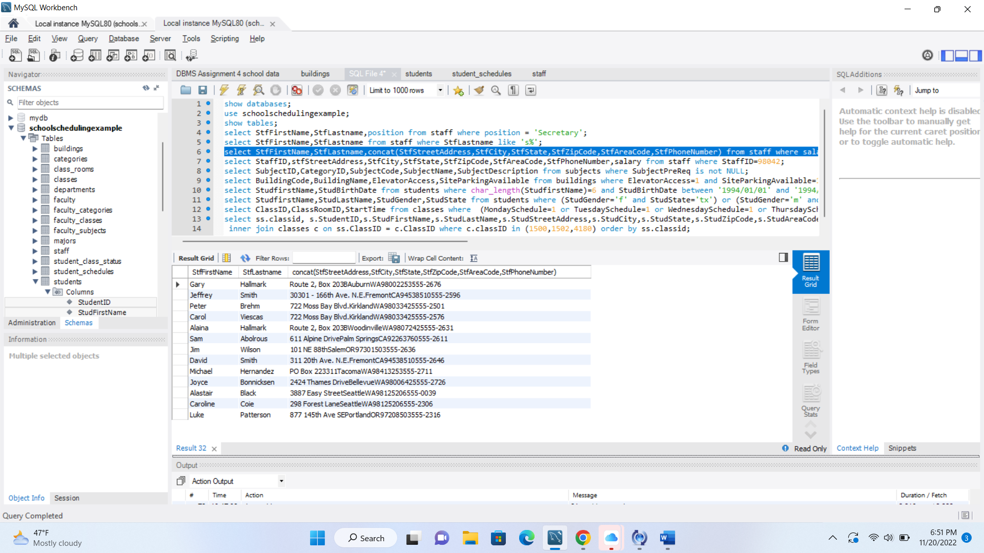

1. **address of the employee with StaffID 98042.**

select

StaffID,

stfStreetAddress,

StfCity,

StfState,

StfZipCode,

StfAreaCode,

StfPhoneNumber,

salary

from

staff

where

StaffID=98042;

1. **list of courses (subjects) with pre-requisites.**

select

SubjectID,

CategoryID,

SubjectCode,

SubjectName,

SubjectDescription

from

subjects

where

SubjectPreReq is not NULL;

1. **list of buildings with access to the parking and elevators.**

select

BuildingCode,

BuildingName

from

buildings

where

ElevatorAccess=1

and

SiteParkingAvailable=1;

1. **list of students that the length of their first name is less than 6 characters and born in 1994.**

select

StudfirstName,

StudBirthDate

from

students

where

char_length(StudfirstName)<6

and

StudBirthDate

between

'1994/01/01' and '1994/12/31';

1. **list of female students from TX and male students from OR.**

select

StudfirstName,

StudLastName,

StudGender,

StudState

from

students

where

(StudGender='f' and StudState='tx')

or

(StudGender='m' and StudState='or')

order by

StudGender;

1. **list of weekday morning classes (Monday - Friday classes that start at or before 11:00:00).**

select

ClassID,

ClassRoomID,

StartTime

from

classes

where

(MondaySchedule=1 or TuesdaySchedule=1 or WednesdaySchedule=1 or ThursdaySchedule=1 or FridaySchedule=1)

and

(StartTime<='11:00:00')

order by

starttime;

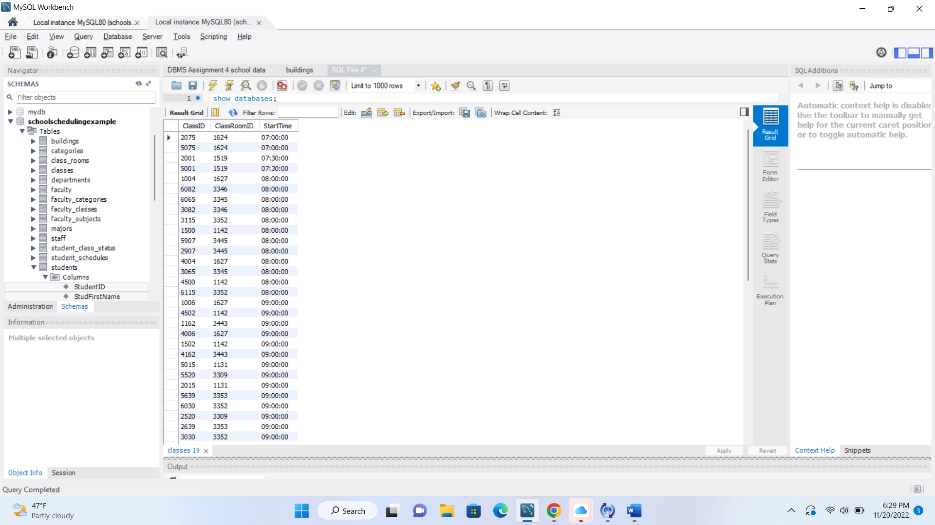

1. **list of students who have classes in the classrooms with classID of 1500,1502,4180.**

Select

ss.classid,

s.StudentID,

s.StudFirstName,

s.StudLastName,

s.StudStreetAddress,

s.StudCity,

s.StudState,

s.StudZipCode,

s.StudAreaCode,

s.StudPhoneNumber,

s.StudBirthDate,

s.StudGender,

s.StudMaritalStatus,

s.StudMajor

from

students s

inner join student_schedules ss on s.StudentID = ss.StudentID

inner join classes c on ss.ClassID = c.ClassID

where

c.classID in (1500,1502,4180)

order by

ss.classid;

